|  |  |
| --- | --- |
| \\VFILERDPI\DPI-Home\OBRIENR2\My Documents\Downloads\PP logo.jpg | Central Coast Council Logo |
| **MEMO TO PANEL**  HUNTER AND CENTRAL COAST REGIONAL PLANNING PANEL | |

|  |  |
| --- | --- |
| PANEL REFERENCE & DA NUMBER | PPSHCC-247 – Central Coast – DA/1474/2023 – 203 Tooheys Road, Bushells Ridge,2259 |
| PROPOSAL | General Industry and Resource Recovery Facility –  Alterations and Additions to Existing Asphalt Plant |
| ADDRESS | Lot 10 DP834953, 203 Tooheys Road, Bushells Ridge |
| APPLICANT | Luke Farrell, Element Environment on behalf of Fulton Hogan Industries Pty Ltd |
| OWNER | Fulton Hogan Industries Pty Ltd |
| DA LODGEMENT DATE | 20 September 2023 |
| APPLICATION TYPE | * Nominated Integrated Development Application (sections 47 & 48 of *Protection of the Environment Operations Act 1997*) * Designated Development Application (clauses 8(1) and 45(2), Schedule 3 of *Environmental Planning and Assessment Regulation 2021*) |
| REGIONALLY SIGNIFICANT CRITERIA | Clause 7(1)(c), Schedule 6 of *State Environmental Planning Policy (Planning Systems) 2021*: waste management facilities or works that meet the requirements for designated development under the *Environmental Planning and Assessment Regulation 2021*, Schedule 3, section 45 |
| CIV | $6,080,956 (excluding GST) |
| RECOMMENDATION | Approval subject to conditions |
| PANEL MEETING DATE | 29 October 2024 |
| PREPARED BY | J Tattam - Senior Development Planner |
| DATE OF MEMO | 24 October 2024 |

**SUPPLEMENTARY INFORMATION**

This memo is to supplement the Officer’s report to the Panel to clarify the zoning of the site, confirm the floor level of the office building and to rectify an error with a recommended condition of consent.

Central Coast Local Environmental Plan 2022

As per the zoning map below the subject site is zoned a combination of E4 General Industrial and C2 Environmental Conservation pursuant to Clause 2.2 of the LEP.

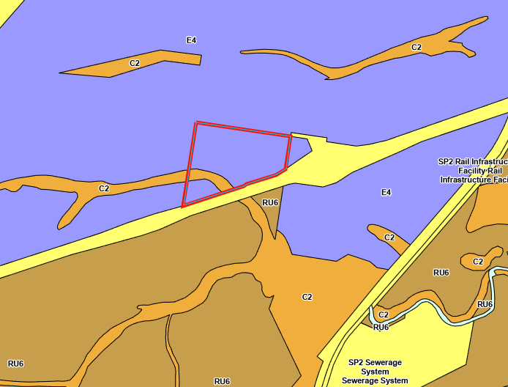

Figure 1: Zoning Map Extract (Source: LEP)

While the Officer’s report addressed the E4 General Industrial zone, it failed to address the C2 Environmental Conservation zone.

The proposed development is wholly located within that portion of the site zoned E4 General Industrial. There are no works proposed within the C2 Environmental Conservation zoned portion of the site.

The objectives of the C2 Environmental Conservation zone are as follows:

* *To protect, manage and restore areas of high ecological, scientific, cultural or aesthetic values.*
* *To prevent development that could destroy, damage or otherwise have an adverse effect on those values.*

The C2 zoning surrounds the Wallarah Creek that is located in the south-western portion of the site. The C2 zoned land and creek are within the Conservation Management Plan (CMP) area and are therefore subject to the restrictions and management requirements under the CMP. This includes actions to manage riparian vegetation and undertake weeding etc. The broader CMP area provides for management of a buffer between the development on the site and the C2 zoned portion of land. Further it is proposed within the recommended conditions of consent that the area will be protected under an s88b instrument.

Further protections to the Wallarah Creek are provided within the General Terms of Approval issued by the EPA which include a requirement for a water pollution discharge assessment. Subject to the EPAs consideration of the water pollution discharge assessment, the applicant may be required to prepare a water management options assessment to identify practical mitigation measures to ensure that any discharges contribute to maintaining or restoring the environmental values of the receiving waterway consistent with the NSW Water Quality Objectives.

It is considered that the proposal is consistent with the objectives of the C2 Environmental Protection zone.

Recommended Condition of Consent

Following finalisation of the recommended conditions of consent it has been identified that recommended Condition 5.6 references the wrong document. Condition 5.6 currently reads (the incorrectly referenced document is highlighted in yellow):

*5.6. Protect the land in identified in Figure 1 of the Conservation Management Plan”, Ver Final 1.0, by Land Eco, dated 1 May 2024 as Conservation Management Area through a 'Restriction on Use' pursuant to section 88B and 'Public Positive Covenant' 88E of the Conveyancing Act 1919.**The area covered by the Covenant must be designated as a ‘Conservation Area to be protected and managed in perpetuity’ with Central Coast Council having the sole authority to remove or modify the Covenants. The Covenants are in general terms to require that:*

* *No structures are to be erected/placed on this land, and no development carried out or permitted except for works detailed in the approved CMP*
* *The approved Site Management Plan (Cool Burn, Ver 1.2, 31 July 2024) must be implemented.*
* *The Conservation Area must be permanently fenced and protected in perpetuity*
* *Weeds must be continually supressed and destroyed and the land must be maintained as an ecologically sensitive area.*
* *All rubbish and other waste is to be removed on a continual basis, with minimum 3 monthly inspections.*
* *The stockpiling of materials or equipment is prohibited.*
* *Provides Council with the authority to inspect the land with 7 days written notice to the registered land owner.*
* *Where the landholder fails to comply with its obligations under the covenant, authority is given to Council to do anything necessary to comply and to recover compensation for any works.*

*Note: Standard wording, acceptable to Council, for covenants can be obtained by contacting Council Subdivision Certificate Officer.*

It is recommended that Condition 5.6 be amended to read as follows (with the correct document highlighted in blue):

*5.6. Protect the land in identified in Figure 1 of the Conservation Management Plan”, Ver Final 1.0, by Land Eco, dated 1 May 2024 as Conservation Management Area through a 'Restriction on Use' pursuant to section 88B and 'Public Positive Covenant' 88E of the Conveyancing Act 1919.**The area covered by the Covenant must be designated as a ‘Conservation Area to be protected and managed in perpetuity’ with Central Coast Council having the sole authority to remove or modify the Covenants. The Covenants are in general terms to require that:*

* *No structures are to be erected/placed on this land, and no development carried out or permitted except for works detailed in the approved CMP*
* *The approved Conservation Management Plan (Ver Final 1.0, by Land Eco, dated 1 May 2024) must be implemented.*
* *The Conservation Area must be permanently fenced and protected in perpetuity*
* *Weeds must be continually supressed and destroyed and the land must be maintained as an ecologically sensitive area.*
* *All rubbish and other waste is to be removed on a continual basis, with minimum 3 monthly inspections.*
* *The stockpiling of materials or equipment is prohibited.*
* *Provides Council with the authority to inspect the land with 7 days written notice to the registered land owner.*
* *Where the landholder fails to comply with its obligations under the covenant, authority is given to Council to do anything necessary to comply and to recover compensation for any works.*

*Note: Standard wording, acceptable to Council, for covenants can be obtained by contacting Council Subdivision Certificate Officer.*

Office Building Floor Level

The Panel has asked to confirm the finished floor level of the new proposed office building.

The applicant has advised that the finished floor level of the building will be approximately RL22.65.

**The draft revised conditions in accordance with the above recommendation are attached to this memo.**